**How to Embed Video & Audio Element**

**Procedure**

**STEP 1:** Open NOTEPAD.

Go to start menu and type notepad then click on it.

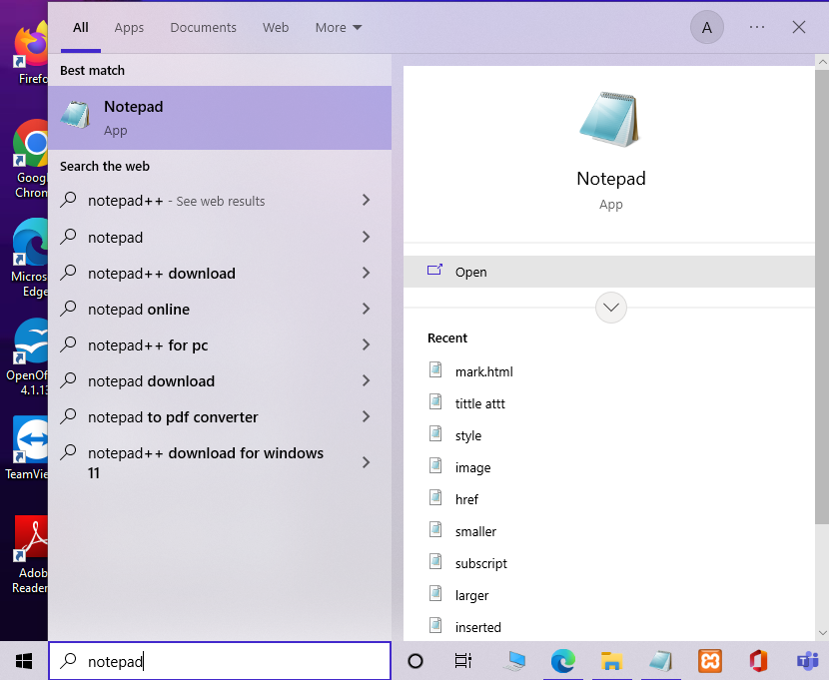

**STEP 2:** Open Notepad then write a code on Notepad.

* Create a program using HTML New Element :

**Program 1:**

**Create a Program Video Element:**

|  |  |
| --- | --- |
| Tag | Description |
| **<video>** | **Video tag define a video file on a web pages.** |

**<video>……………………………………………………………………………..</video>**

**Write a code:**

<! DOCTYPE html>

<html>

<head>

<title>

HTML NEW Element

</title>

</head>

<body>

<h1>HTML NEW ELEMENT</h1>

<H3>Example of VEDIO Element</h3>

<video width="300" height="200" controls autoplay> <!--Video Element-->

<Source src="C:\Users\ghmun\Downloads\rock.mp4"/>

Your browser does nnot support the vedio element.

</video>

</body>

</html>

* Then save the file{video.html} (Ctrl+s).

**OUTPUT:** Open the file on chrome browser then see the output.

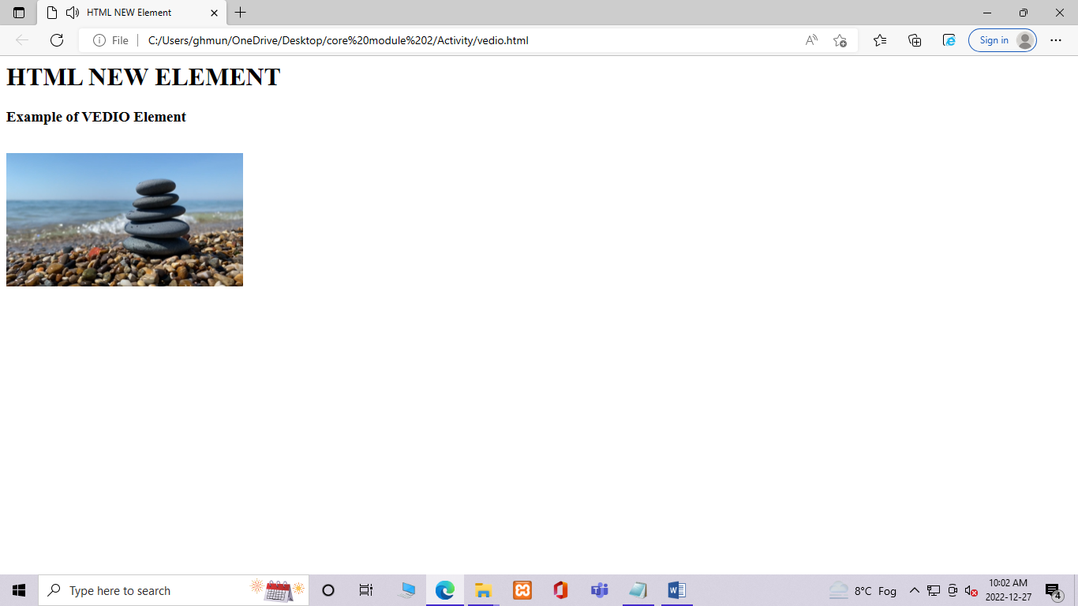

**Program 2:**

**Create a Program Audio Element:**

|  |  |
| --- | --- |
| Tag | Description |
| **<audio>** | **Audio tag define an Audio file on a web pages.** |

**<audio>……………………………………………………………………………..</audio>**

**Write a code:**

<! DOCTYPE html>

<html>

<head>

<title> HTML NEW Element </title>

</head>

<body>

<h1>HTML NEW ELEMENT</h1>

<H3>Example of AUDIO Element</h3>

<audio controls autoplay> <!--audio Element-->

<Source src="C:\Users\ghmun\Downloads\1234.mp3"/>

Your browser does not support the audio element.

</audio>

</body>

</html>

* Then save the file {audio.html} (Ctrl+s).

**OUTPUT:** Open the file on chrome browser then see the output.

